
Engage Students. Empower Teachers.

Dear Parents,
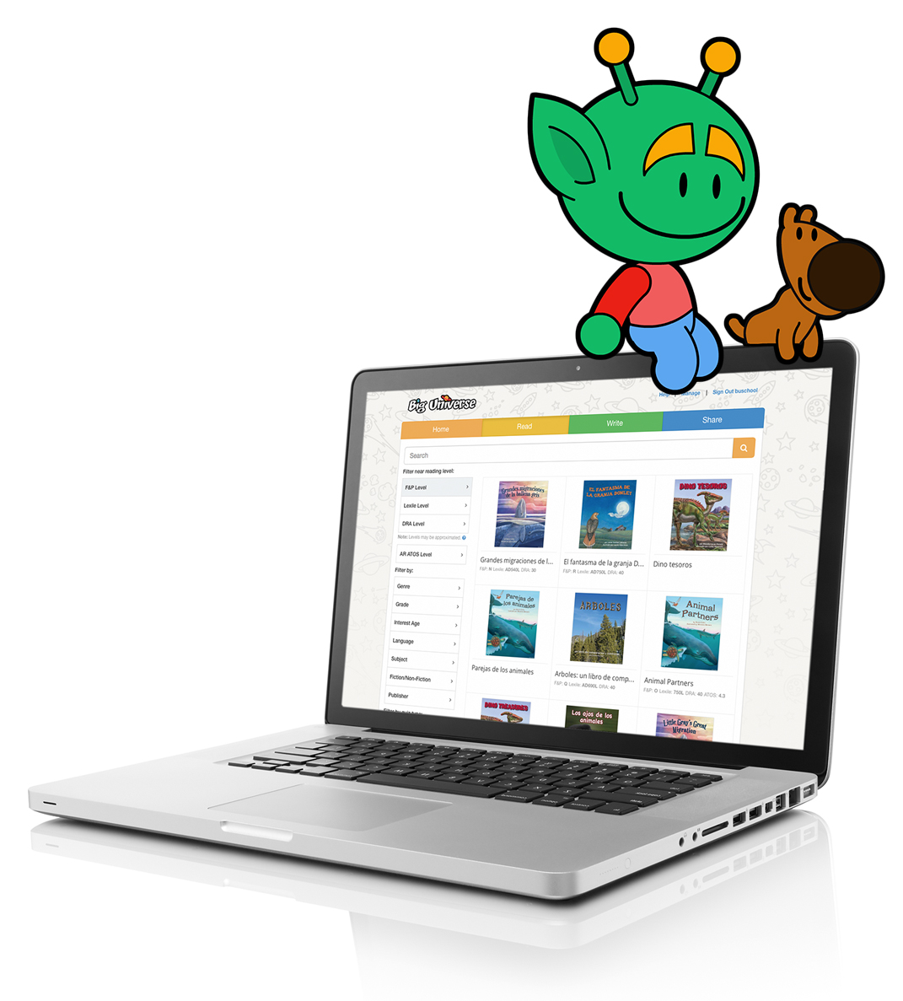
This year, our school will be using Big Universe, an award winning online literacy platform designed to instill the love for reading, writing, and learning in your students. We are excited about this literacy tool and think you will be happy to know this resource is accessible 24/7 at home on any device. Have your child read the books each week if possible. Email me if you have any questions. Thanks so much, Mrs. Flowers.
To get your child started at home, please follow these easy steps:
- Go to www.biguniverse.com and click Sign In
- Enter your account information:
Username: wcp (plus lunch number); example: wcp123456789
Password: (lunch number only); example: 123456789
Group Username: wcpss
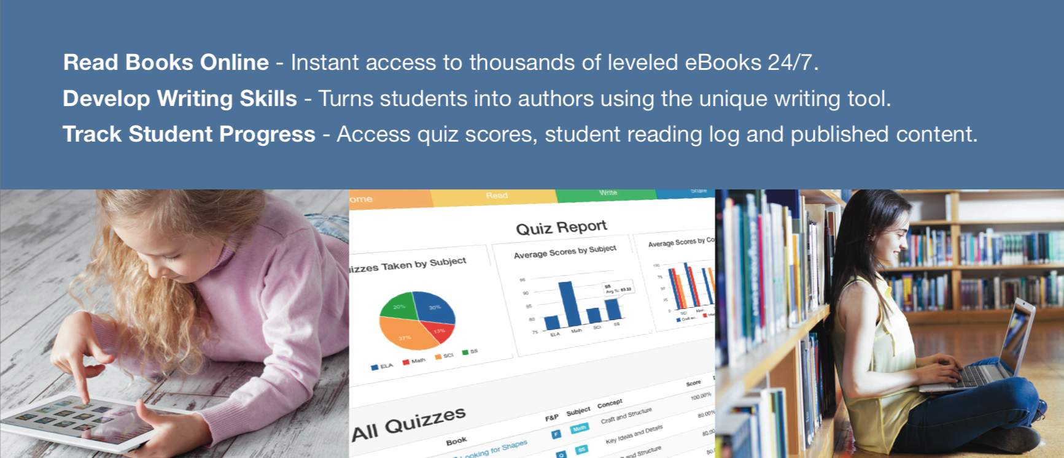
For additional information, visit www.biguniverse.com/help or contact Big Universe at support@biguniverse.com
Big Universe, Inc., 11654 Plaza America Drive, Suite 143, Reston, Virginia 20190 (USA)
Tel: +1 877.360.READ Fax: +1 877.360.WRIT info@biguniverse.com www.biguniverse.com

